Chapter 7, Problem 19.

In the circuit of Fig. 7.99, find i(t) for t > 0 if i(0) = 6 A.

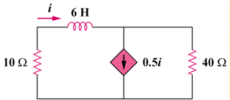

Figure 7.99
For Prob. 7.19.

